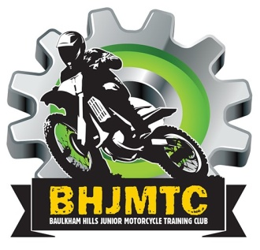

Baulkham Hills Junior Motorcycle Training Club Inc.
Invite you to join us for our
Annual Christmas Party & Trophy Presentation
Sunday, 27th November 2016
3.00pm to 7.00pm
(Trophy Presentation: 3.30pm, Dinner: 5.00pm, Santa: 6.30pm)
Where: John Benyon Rotary Park, 135 Kenthurst Rd, Kenthurst NSW 2156
What to bring: chairs or picnic rug, shade gazebo, basket ball, snacks
Cost: $25.00 per family (financial members, siblings and parents)
$10.00 for each additional NON-MEMBER ADULT (Grandparents etc.)
$5.00 for each additional NON-MEMBER CHILD (Cousins / Friends)
RSVP and Payment: To ensure numbers for catering please email this completed invitation to events@bhjmtc.com.au along with confirmation receipt of payment by Tuesday 22nd November 2016.
Challenge yor friends and family on the giant inflatable obstacle course
Direct Deposit Details Bank: National Australia Bank
Account Name: Baulkham Hills Junior Motorcycle Training Club BSB: 0 8 2 1 3 3 Account No: 0 3 9 3 4 1 5 3 1

BAULKHAM HILLS JUNIOR MOTORCYCLE TRAINING CLUB
2016 ANNUAL CHRISTMAS PARTY & PRESENTATION DAY
FAMILY NAME: | CONTACT NO:
Names of Adults Attending: | Names of Children Attending:
Names of Non-Member Adults Attending: | Names of Non- Member Children Attending:

